Differential Temperature Sensor

1. Introduction

This article is about differential operational amplifier temperature sensor preamplifier biasing circuits. Two circuits are explained in this article. The first one is the bridge circuit connected to a differential amplifier. The second is a differential amplifier circuit connected to a voltage divider circuit where R1 is the thermistor.

We will try to determine which circuit is the most linear.

The difference between thermistor and thermocouple is that thermocouple is more of a complete circuit that provides a voltage output proportional to temperature while thermistor is a resistor that changes resistance with temperature. Higher temperature reduces the resistance of the thermistor because higher temperature improves the conduction of the circuit.

I used Octave Software instead of Matlab.

2. Thermistor Resistance

Resistance of negative temperature coefficient (NTC) thermistor is given by:

$R_{th1}=r_{α}e^{\frac{β}{T}}$

Where: $r_{α}=R_{0}e^{-\frac{β}{T_{0}}}$
$β=$ Beta Parameter (Kelvin)$=\frac{T_{50}×T_{0}}{T_{50}-T_{0}}ln\left(\frac{R_{0}}{R_{50}}\right)$
$R_{0}$=Thermistor Resistance at 25 degree temperature ($Ω$)
$R_{50}$=Thermistor Resistance at 50 degree temperature ($Ω$)
$T_{0}$= Room Temperature (Kelvin) = ${25}^{∘}C$ + 273.15 Kelvin
$T_{50}$= 50 Degree Temperature (Kelvin) = ${50}^{∘}C$ + 273.15 Kelvin
T = Ambient Temperature (Kelvin)

However, you can also approximate the equation above as a straight line with a gradient and intercept:

$R_{th2}$ =$\frac{R_{0}\left(\frac{1}{exp(β/3854)}-1\right)}{25}$$×$(T - 25) + $R_{0}$

We can use those formulas to plot thermistor resistance versus temperature:

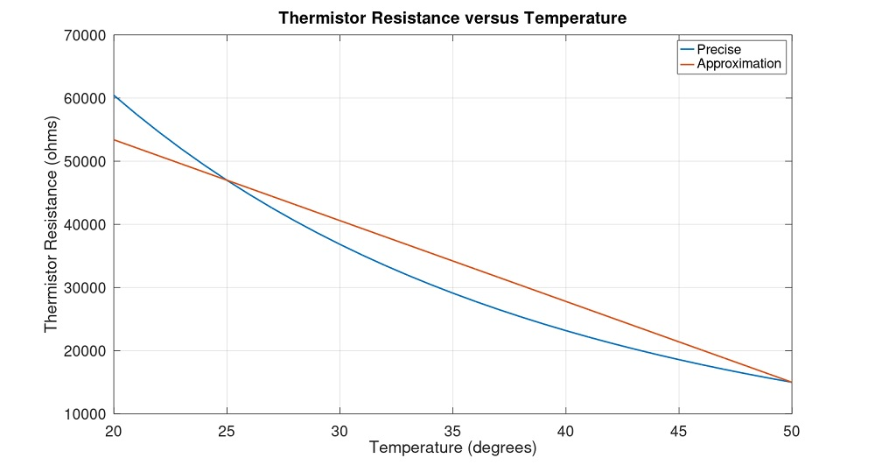
Figure 1: Thermistor Resistance versus Temperature.

3. Bridge Circuit

The bridge circuit was designed for low voltage difference between two differential amplifier inputs to avoid output saturation:

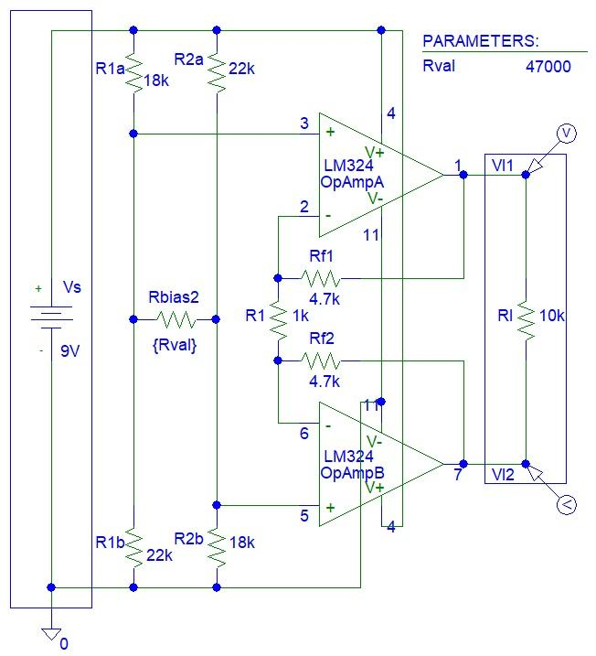
Figure 2: Bridge Circuit.

The Matlab and PSpice simulations seemed to be matched:
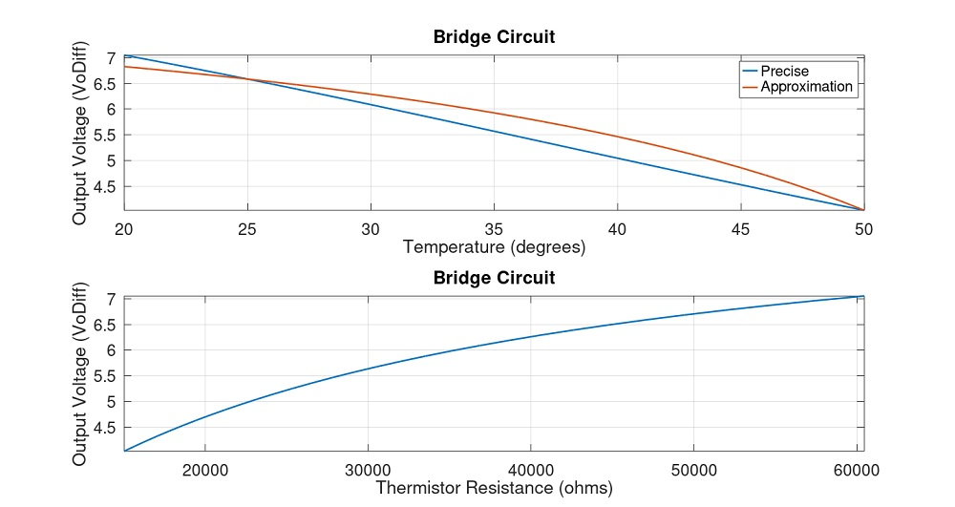
Figure 3: Matlab Simulations.

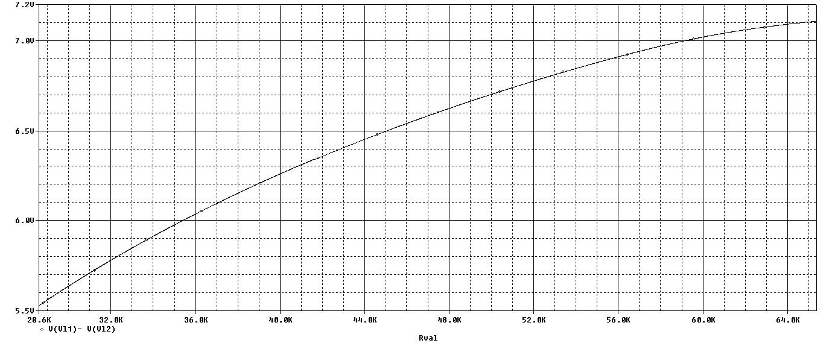
Figure 4: PSpice Simulations.

4. R1 is Thermistor Circuit
The circuit was designed so that the difference between two differential amplifier inputs is approximately 1 V:
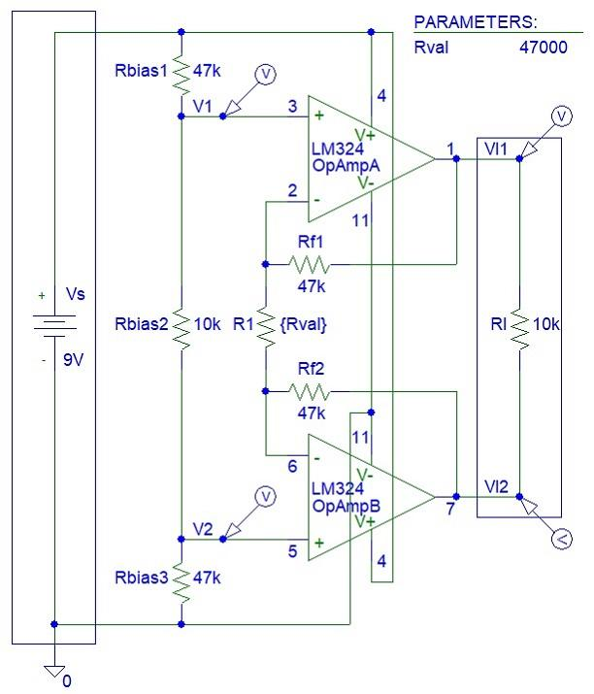
Figure 5: R1 is Thermistor Circuit.

The Matlab and PSpice simulations seemed to be matched:
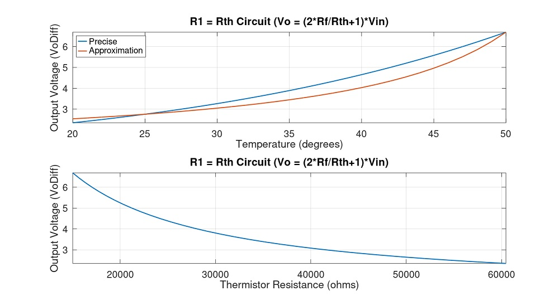
Figure 6: Matlab Simulations.

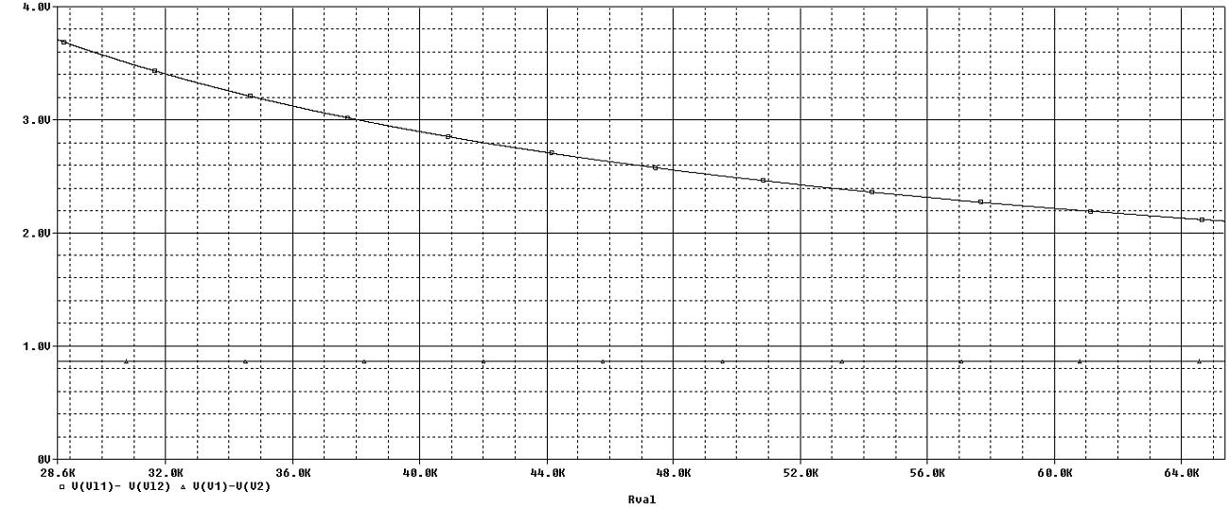
Figure 7: PSpice Simulations.

5. Conclusion

Matlab and PSpice simulations show that both circuits have similar linear characteristics and no circuit is more linear than the other.

I also considered a circuit where two thermistors are connected instead of Rf1 and Rf2 resistors. However, such circuits are not possible in practice because Rf1 and Rf2 need to be matched to minimise the common mode gain. It is hard to find two thermistors with similar resistance values.

An article on operational amplifier biasing circuits was published by Analogue Electronics project funded by various non profit organisations. I suggest that you read this article.

Refer to the appendix for Matlab code.

Charles Amplayo, Panglao, Bohol, Philippines

6. Appendix
clear all; close all;

Vs=9;
MinTemp=20;
MaxTemp=50;
Beta=4400;
R25=47000;
AbsZero=273.15;
LnWd=2;
FtSz=20;
FtSzAxes=20;

% Calculations
disp(['Maximum Temperature = ' num2str(MaxTemp) ' degrees'])
disp(['Thermistor Resistance at 25 degrees = ' num2str(R25) ' ohms'])

BetaPart1=(25+AbsZero)*(50+AbsZero)/25;
Gradient=(R25/exp(Beta/BetaPart1)-R25)/25;
Rth25=R25;
Rth50=Gradient*(MaxTemp-25)+R25;
BetaCheck=BetaPart1*log(Rth25/Rth50);
disp(['Beta = ' num2str(Beta)])
disp(['BetaCheck = ' num2str(BetaCheck)])

Temp=[MinTemp:1:MaxTemp];
ra=R25*exp(-Beta/(25+AbsZero));
Rth1=ra*exp(Beta./(Temp+AbsZero));
Rth2=Gradient*(Temp-25)+R25;

figure
plot(Temp,Rth1,'LineWidth',LnWd,Temp,Rth2,'LineWidth',LnWd)
legend('Precise','Approximation','FontSize',FtSz)
title('Thermistor Resistance versus Temperature','FontSize',FtSz)
xlabel('Temperature (degrees)','FontSize',FtSz);
ylabel('Thermistor Resistance (ohms)','FontSize',FtSz);
H=gca;set(H,'fontsize',FtSzAxes);
grid on

disp(['Minimum Thermistor Resistance = ' num2str(min(Rth1)) ' ohms'])
disp(['Maximum Thermistor Resistance = ' num2str(max(Rth1)) ' ohms'])

% First Circuit
disp(['Vs = ' num2str(Vs) ' V'])
Gain=2*4700/1000+1;
R1a=18000;
R1b=22000;
R2a=22000;
R2b=18000;
Rthvn1=R1a*R1b/(R1a+R1b);
Rthvn2=R2a*R2b/(R2a+R2b);
Vthvn1=R1b*Vs/(R1a+R1b);
Vthvn2=R2b*Vs/(R2a+R2b);
VinA=(Vthvn1-Vthvn2).*Rth1./(Rthvn1+Rth1+Rthvn2);
VoDiff1a=VinA*Gain;
VinB=(Vthvn1-Vthvn2).*Rth2./(Rthvn1+Rth2+Rthvn2);
VoDiff1b=VinB*Gain;

figure;
subplot(2,1,1)
plot(Temp,VoDiff1a,'LineWidth',LnWd,Temp,VoDiff1b,'LineWidth',LnWd)
legend('Precise','Approximation','FontSize',FtSz)
axis([min(Temp) max(Temp) min(VoDiff1a) max(VoDiff1a)])
title('Bridge Circuit','FontSize',FtSz)
xlabel('Temperature (degrees)','FontSize',FtSz);
ylabel('Output Voltage (VoDiff)','FontSize',FtSz);
H=gca;set(H,'fontsize',FtSzAxes);
grid on
subplot(2,1,2)
plot(Rth1,VoDiff1a,'LineWidth',LnWd)
title('Bridge Circuit','FontSize',FtSz)
axis([min(Rth1) max(Rth1) min(VoDiff1a) max(VoDiff1a)])
xlabel('Thermistor Resistance (ohms)','FontSize',FtSz);
ylabel('Output Voltage (VoDiff)','FontSize',FtSz);
H=gca;set(H,'fontsize',FtSzAxes);
grid on

% Second Circuit
Rf=47000;
Vin=0.92;

R1=Rth1;
GainA=2*Rf./R1+1;
VoDiff2a=Vin*GainA;

R1=Rth2;
GainB=2*Rf./R1+1;
VoDiff2b=Vin*GainB;

figure;
subplot(2,1,1)
plot(Temp,VoDiff2a,'LineWidth',LnWd,Temp,VoDiff2b,'LineWidth',LnWd)
legend('Precise','Approximation','FontSize',FtSz,'location','NorthWest')
axis([min(Temp) max(Temp) min(VoDiff2a) max(VoDiff2a)])
title('R1 = Rth Circuit (Vo = (2*Rf/Rth+1)*Vin)','FontSize',FtSz)
xlabel('Temperature (degrees)','FontSize',FtSz);
ylabel('Output Voltage (VoDiff)','FontSize',FtSz);
H=gca;set(H,'fontsize',FtSzAxes);
grid on
subplot(2,1,2)
plot(Rth1,VoDiff2a,'LineWidth',LnWd)
title('R1 = Rth Circuit (Vo = (2*Rf/Rth+1)*Vin)','FontSize',FtSz)
axis([min(Rth1) max(Rth1) min(VoDiff2a) max(VoDiff2a)])
xlabel('Thermistor Resistance (ohms)','FontSize',FtSz);
ylabel('Output Voltage (VoDiff)','FontSize',FtSz);
H=gca;set(H,'fontsize',FtSzAxes);
grid on

